**PRACTICAL 3 : Traffic Signal**

**Aim :** To simulate a traffic signal system using LEDs and Arduino.

**Overview :**

This project simulates a real-world traffic light system using LEDs and Arduino. It introduces concepts of sequential control, timing and real-time decision-making, which are essential in IoT-based automation systems. The practical helps in understanding how microcontrollers manage multi-step processes.

**Materials Required :**

* Arduino Uno R3
* 3 x LED (Red, Yellow, Green)
* 3 x 1kΩ Resistor
* Jumper Wires
* Arduino IDE (Installed on your Computer)

**Circuit Connection and Steps :**

1. **Connect the LEDs to the Arduino :**
   * Insert the three LEDs (Red, Yellow, Green) into the breadboard.
   * Connect the anode (long leg) of each LED to the following Arduino pins :
     + Red LED : Pin 13
     + Yellow LED : Pin 12
     + Green LED : Pin 11
   * Connect the cathode (short leg) of each LED to the ground (GND) pin on the Arduino through a 1kΩ resistor.
2. **Set up the Arduino environment:**
   * Open the Arduino IDE on your computer.
   * Select the correct board and port from the "Tools" menu.

**Circuit Diagram :**

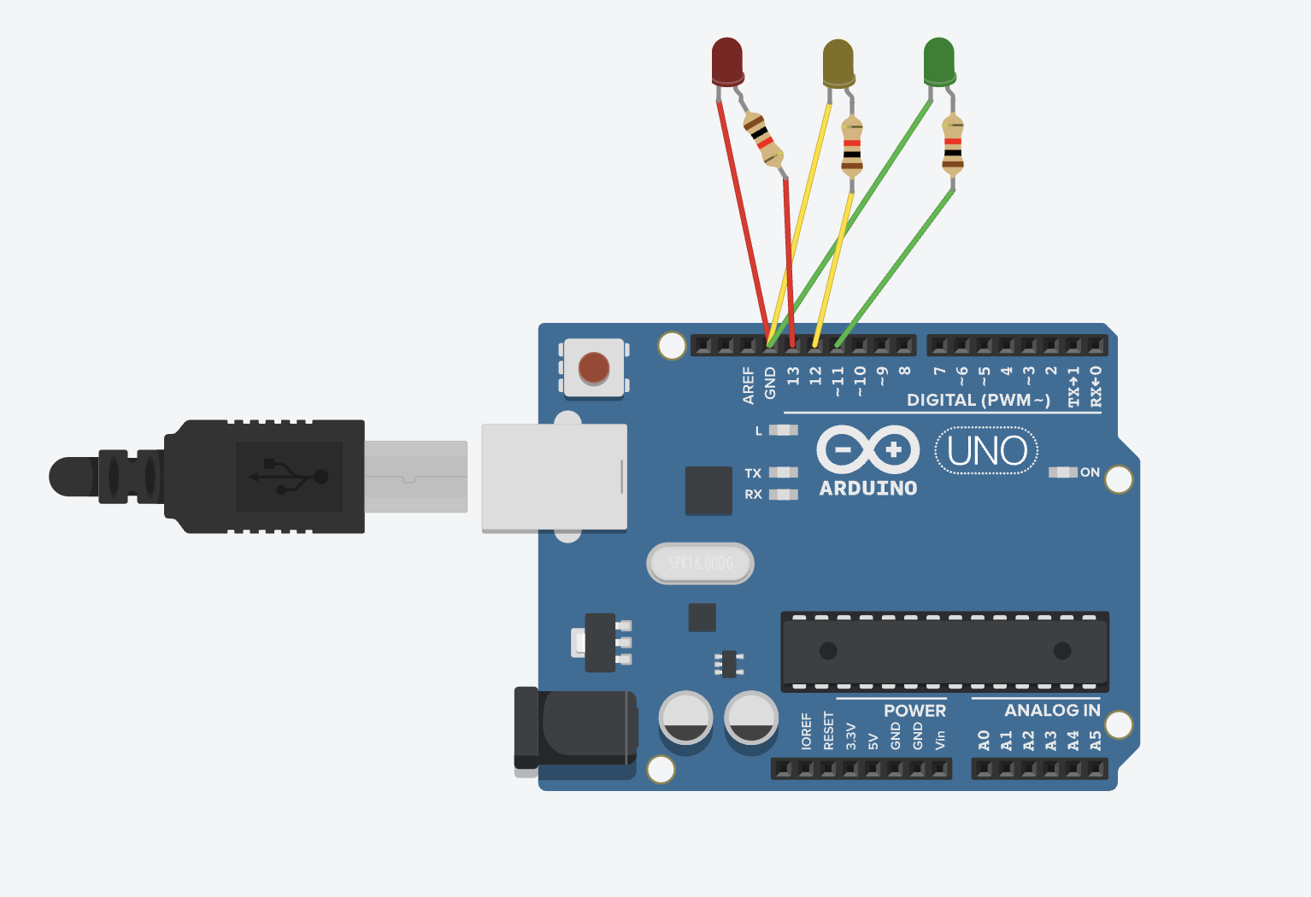

**Schematic Diagram :**

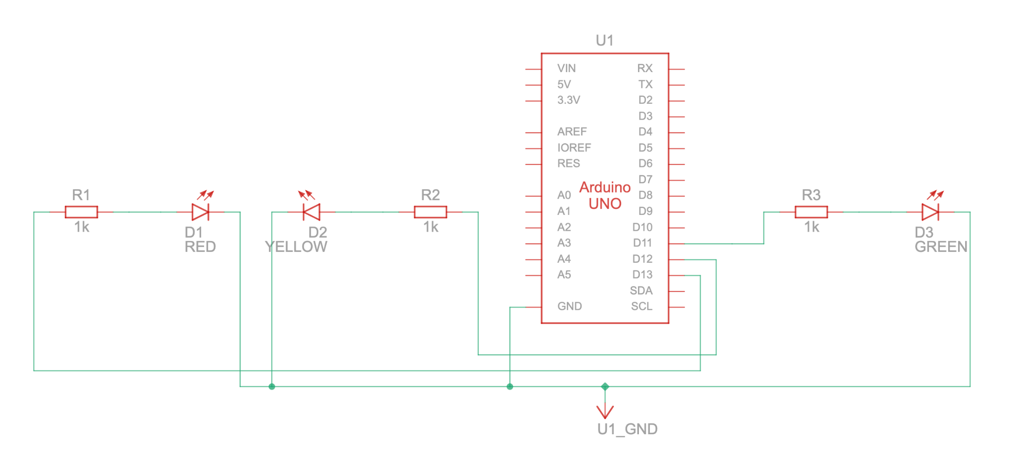

**Code :**

// C++

// Define the pin connections for the LEDs

int redPin = 13;

int yellowPin = 12;

int greenPin = 11;

// Setup function runs once when the program starts

void setup() {

// Set the LED pins as OUTPUT

pinMode(redPin, OUTPUT);

pinMode(yellowPin, OUTPUT);

pinMode(greenPin, OUTPUT);

}

// Loop function runs repeatedly

void loop() {

// Green light for 5 seconds

digitalWrite(greenPin, HIGH); // Turn on Green LED

digitalWrite(yellowPin, LOW); // Turn off Yellow LED

digitalWrite(redPin, LOW); // Turn off Red LED

delay(5000); // Wait for 5 seconds

// Turn off Yellow LED

// Yellow light for 2 seconds

digitalWrite(greenPin, LOW); // Turn off Green LED

digitalWrite(yellowPin, HIGH); // Turn on Yellow LED

digitalWrite(redPin, LOW); // Turn off Red LED

delay(2000); // Wait for 2 seconds

// Red light for 5 seconds

digitalWrite(greenPin, LOW); // Turn off Green LED

digitalWrite(yellowPin, LOW); // Turn off Yellow LED

digitalWrite(redPin, HIGH); // Turn on Red LED

delay(5000); // Wait for 5 seconds

}

**Results :**

The traffic signal system will cycle through the following pattern :

* The Green LED will light up for 5 seconds (allowing traffic to go).
* The Yellow LED will light up for 2 seconds (indicating the transition from Green to Red).
* The Red LED will light up for 5 seconds (indicating a stop for traffic). This cycle will repeat indefinitely, simulating a basic traffic signal system

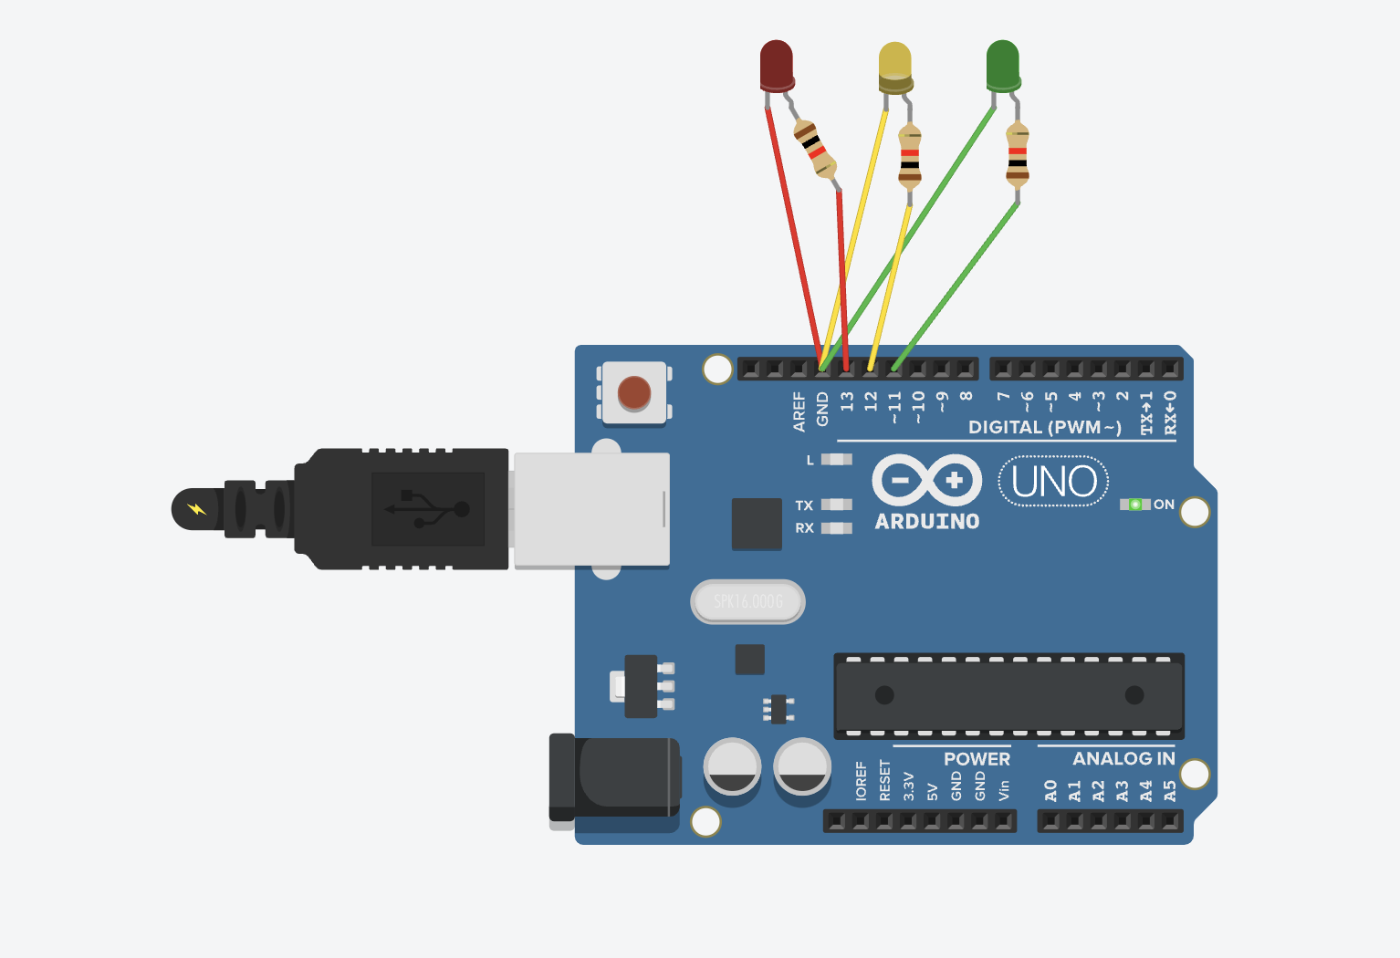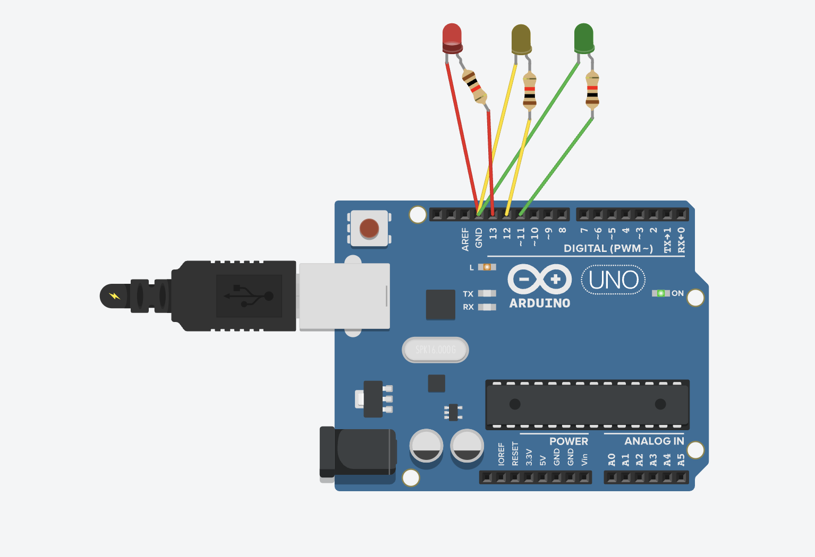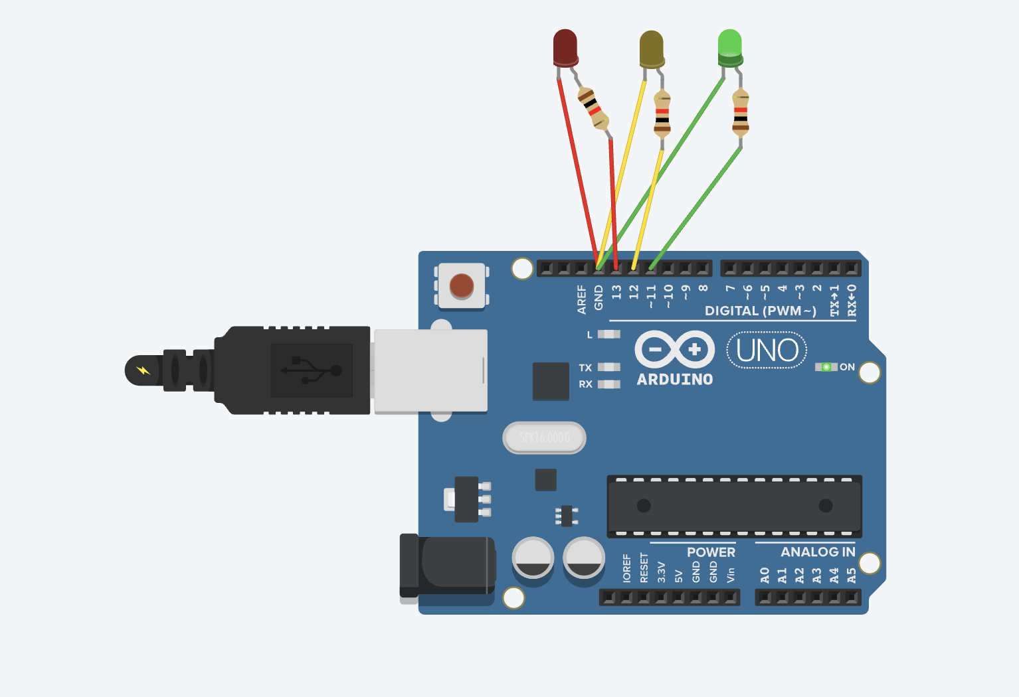

**Conclusion :**

The Traffic Signal project successfully simulates real-world traffic light control using Arduino. It demonstrates the concept of sequential execution, timing control and LED management. This experiment provides insight into automation in smart city applications and real-time embedded system design.